**Pulling a Web Connect File**

1. Login to iBanking. Make sure that your iBanking password does not include the symbols < > &.

These are not allowed for web connect users.

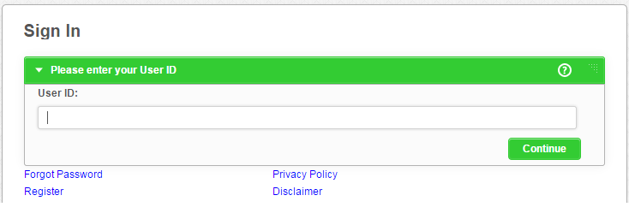

1. Navigate to the Profile > Service Center > Quicken/Quickbooks Module.

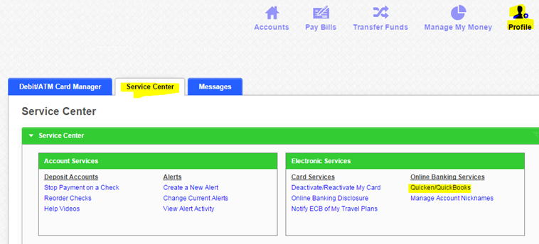

1. In the Web Connect module please select your account and click the “Other” radio button. Here you

have to select what range of data you want to pull into QuickBooks online. Please double check your

Quickbooks Online to see which date range is missing. Choosing the correct range here will prevent

duplicate transaction entries. For software version select QuickBooks Online, if you do not see that as an

option, then please select any QuickBooks Windows version. For example you can choose QuickBooks

Windows 2013.

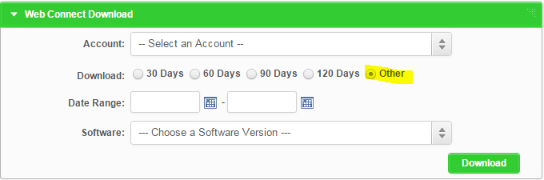

1. Next click the download button and save the file in a location where you can find it. Saving it to your

desktop may make it easy to find.

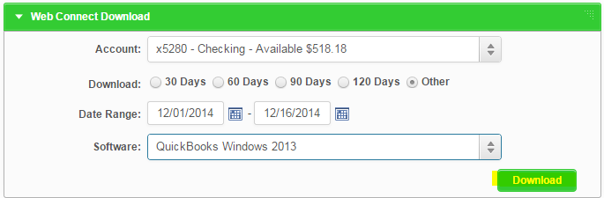

**Uploading to Quicken**

1. Open Quicken and navigate from the top menus to File>File Import>Web Connect File

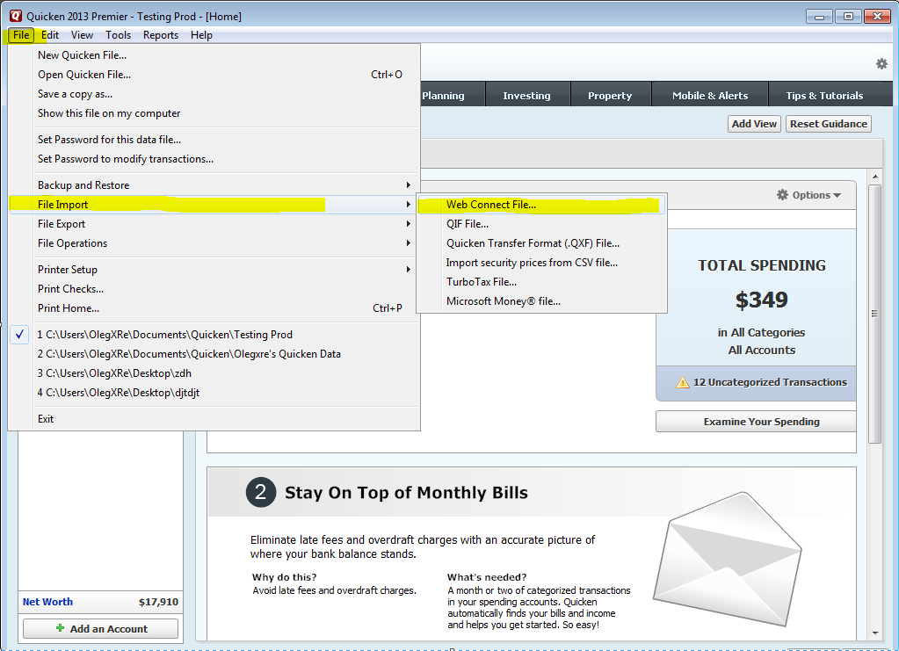

1. Navigate to the location where you saved your web connect file and select it.

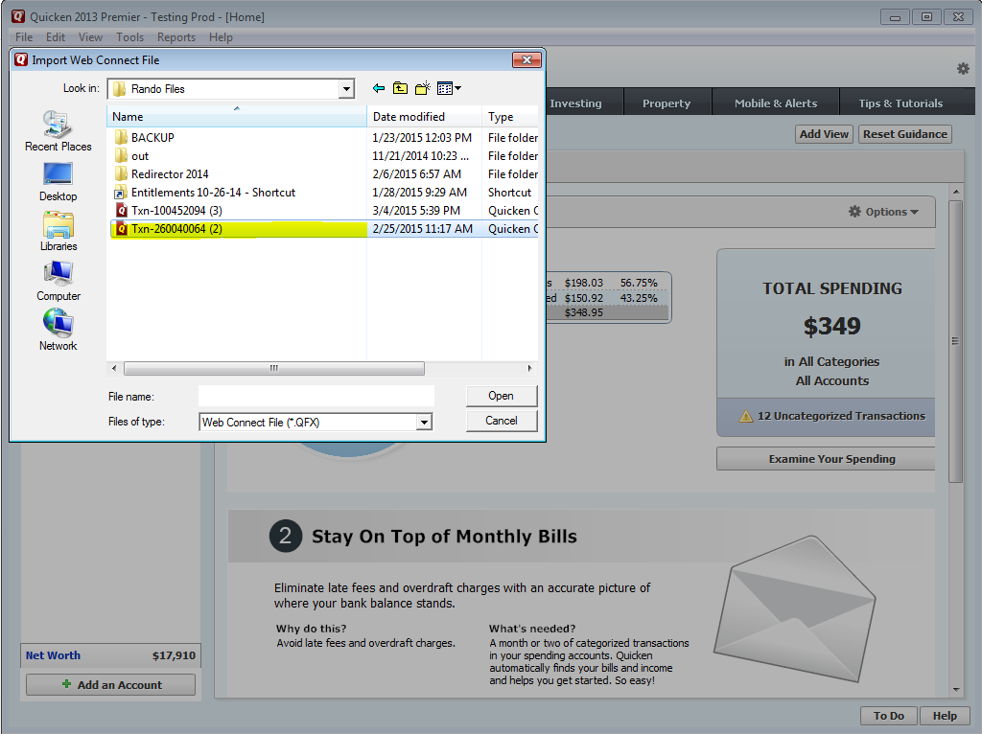

1. If this is the first time that you are downloading transactions for this account, then choose create a new account. You can click Link to an existing account if you have previous downloads for this account.

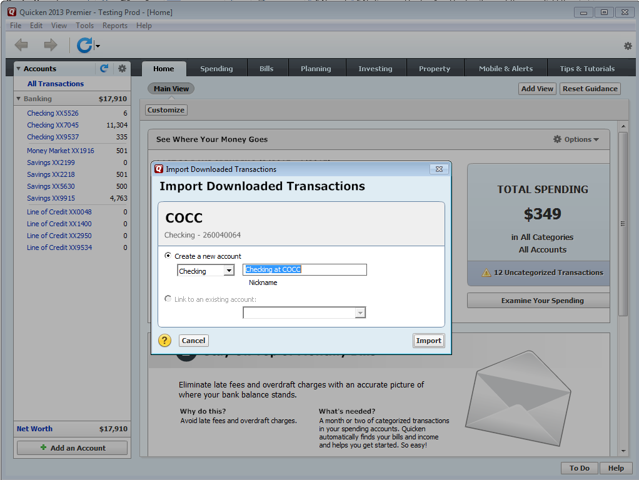

**Uploading to QuickBooks**

1. Open QuickBooks and navigate from the top menus to Banking>Bank Feeds>Import Web Connect File.

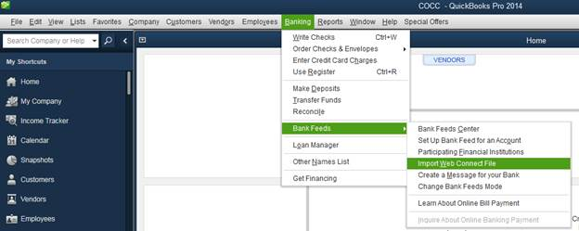

1. Next you have to select the file from the location you saved it to.

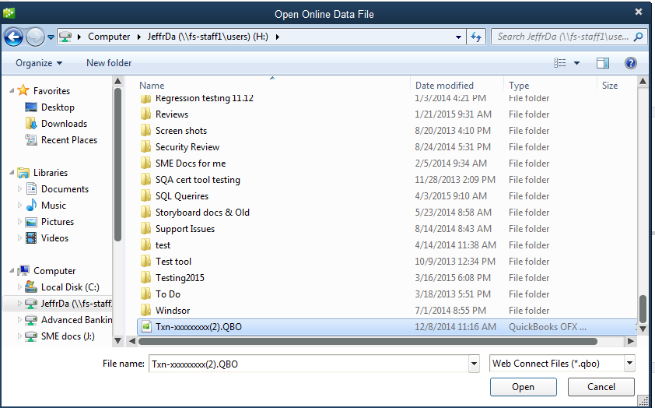

1. Make sure to select link to existing accounts if you have previously downloaded transaction for this account.

**Uploading to QuickBooks Online**

1. Select the account you wish to update in QuickBooks Online.

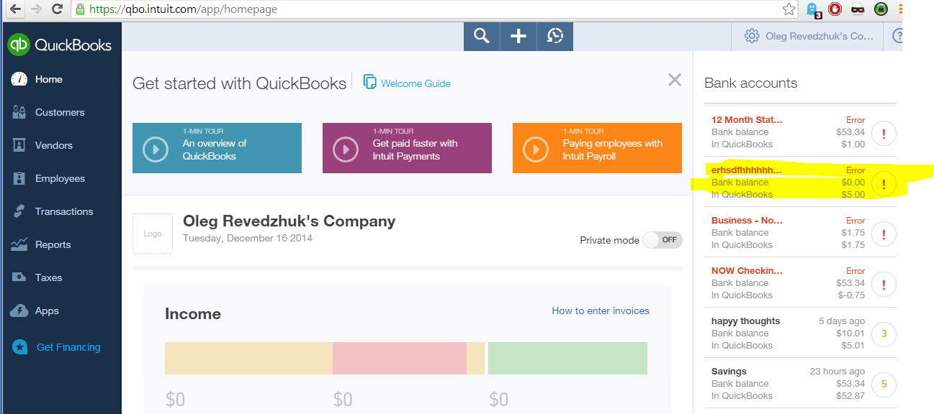

1. Click update > File Upload. Please make a note of the name of the account you would like to update.

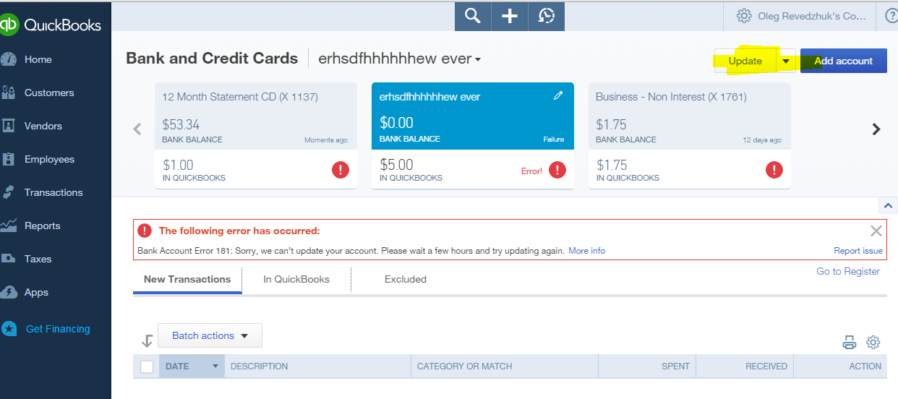

1. Click Browse and find the file you downloaded previously. It should be a QBO file type with a similar name to the screenshot. Then click next on the bottom right.

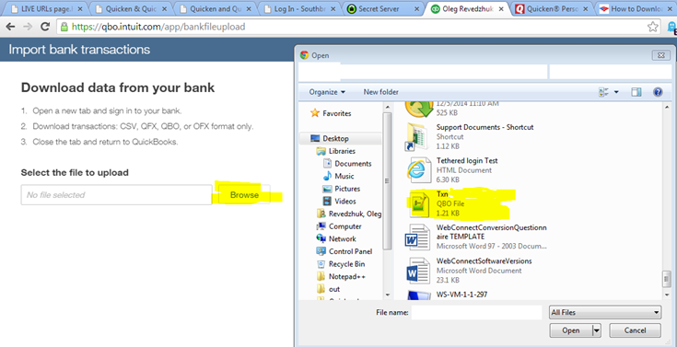

1. Select the account you would like to update and click next.

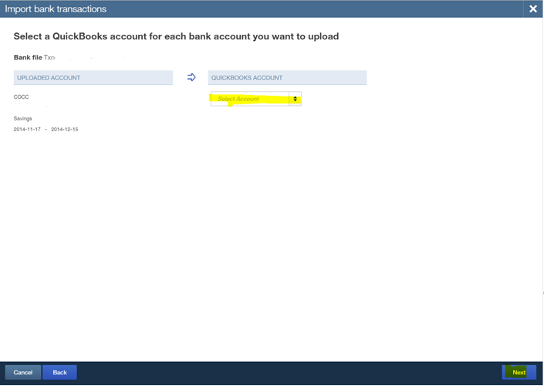

1. The next screen warns you about duplicate transactions, as long as we selected the correct date range in iBanking there should be no problems. Click next.

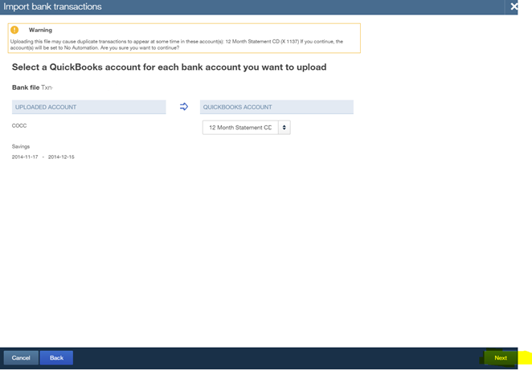

1. The system should now update your accounts. After you are done with using web connect files and any connection issues are resolved please go to your account and update the sign-in info.

